# nit Military

# STOP: mp3 stop in Unit III

# Lexical resource

modal /ˈməʊdəl/ [N-COUNT](javascript:;)In grammar, a modal or a modal auxiliary is a word such as "can" or "would" which is used with a main verb to express ideas such as possibility, intention, or necessity. 情态动词

|  |
| --- |
| [juː'tens(ə)l] utensil  [N-COUNT](javascript:;)Utensils are tools or objects that you use in order to help you to cook, serve food, or eat. 器皿; 用具  •  ...utensils such as bowls, steamers and frying pans.  …碗、蒸锅、平底锅等用具。  [词条图片](javascript:;)  V.S. 炊具；烹饪用水果；窜改者cooker /ˈkʊkə/  [N-COUNT](javascript:;)A cooker is a large metal device for cooking food using gas or electricity. A cooker usually consists of an oven, a grill, and some gas burners or electric rings. 厨灶  [词条图片](javascript:;) |
|  |
|  |
|  |
| 熄灯；熄灯号；就寝时间 lights out  [N](javascript:;)the time when those resident at an institution, such as soldiers in barracks or children at a boarding school, are expected to retire to bed 就寝时间  e.g. |
| [给sb.慢慢地灌输xxx: instill sth **in**sb. = instill **in** sb sth ] |
| 健美体操 [,kælɪs'θenɪks] calisthenics: [N-PLURAL](javascript:;)Calisthenics are simple exercises that you can do to keep fit and healthy. 软体操    [词条图片](javascript:;) |
| [ cock V.S. cork软木塞. 软木 ]   * n. 公鸡, an adult male chicken 公鸡, cock=rooster V.S. hen母鸡　e.g. A cock crowed in the distance. 远处有只公鸡在打鸣 * cock: an adult male bird of any kind 雄鸟，雄禽 * 龙头头目 cock e.g. He’s the cock of that **criminal syndicate**.　他是那个 黑社会 的龙头头目 * vt. 使朝上竖起；使朝上耸立；大摇大摆 * SEX ORGAN, informal, not polite a penis= cock 鸡巴，屌   e.g.   |  | | --- | | InterStar Airways Flight 293, landed at San Francisco International Airport (SFO), San Francisco, California, with the nose wheels cocked**机头朝上竖起** at 90 degrees, which **is upwards perpendicular to** the ground. | | Pilot: **“Pan-pan call/distress call”** “This is InterStar Two **Niner Tree**. I am two miles south of Oakland. The controls indicate that there is a landing gear **shock absorber** fault (//emergency of a mechanical failure). The landing gear is currently down I have **three green**. It tells me not to **retract收回 the gear**. I'm also showing a nose steering fault. It shows that the landing gear **is perpendicular to center (和xx垂直成直角),** that is 90 degrees off center. **Do you copy? Over**.”  ATC: **Copy that**, Two Niner Three. Stand by so that we can figure out a course of action for you. We may have you land at San Jose, which is the closest airport for you.  Pilot: I can go to San Jose or some other destination if it calls for that. Does San Jose **have crash, fire and rescue capability**? I want to know what the winds are as well down there. If I've got high **crosswinds** with **a cocked nose朝上竖起的机头**in the landing gear, I'm not very interested in going down there. | |
| ['bɒɪən**sɪ**] buoyan**cy** 〔物体在液体里的〕浮性; 〔液体的〕浮力 ; 自信乐观心情；（股票）保持高价或回升  **[ life buoy = life belt, life ring 救生圈 ]**  **[****buoyancy correction****浮力修正;** **buoyancy factor****浮力系数; buoyancy force: 浮力 ]**  [词条图片](javascript:;)   1. the ability of an object to float in liquid, like water, sea〔物体在液体里的〕浮性 2. the power of a liquid to make an object float〔液体的〕浮力   e.g. Salt water has more buoyancy than fresh water. 盐水的浮力比淡水大。  e.g. Note that this includes the buoyancy of the bubble wrap, so it isn’t the real density.  考虑到汽泡纸（在空气中）具有一定的浮力，因此这并非它真正的密度  3. a feeling of happiness and a belief that you can deal with problems easily 自信；乐观 |

# Lexical_dicRelatedWithMilitary

|  |
| --- |
| fatigue /fəˈtiːɡ/  1.[N-UNCOUNT](javascript:;)Fatigue is a feeling of extreme physical or mental tiredness. 疲惫  •  She continued to have severe **stomach cramps胃痉挛**, aches, fatigue疲惫, and depression  2. [N-UNCOUNT](javascript:;)You can say that people are suffering from a particular kind of fatigue when they have been doing something for a long time and feel they can no longer continue to do it. 疲乏  •  ...compassion fatigue caused by endless TV and celebrity appeals.  …电视和名人无休止的呼吁所引起的怜悯疲劳。  🡺 **fatigued: He's fatigued**. Really tired. He may be suffering from exhaustion.  3.[N-UNCOUNT](javascript:;)**Fatigue in metal or wood is a weakness in it that is caused by repeated stress. Metal fatigue or wood fatigue can cause the metal or wood to break. (金属、木材的) 疲劳  [ metal fatigue; wood fatigue]**  e.g. The problem boils down to the **metal fatigue** in the fuselage.  机身的金属疲劳。  4.[**N-PLURAL复数**](javascript:;)**Fatigues** are clothes that soldiers wear when they are fighting or when they are doing routine jobs. 军服 **[作战服, 军服combat fatigues]**  •  He never expected to return home wearing **combat fatigues.** 他从未想到会穿着作战服回家。 |
|  |
| /'redʒɪmənt,'redʒəmənt,ˋrɛdʒəmənt/ n. [C ]  英 ['redʒɪmənt,'redʒəmənt]   1. a large group of soldiers, usually consisting of several battalion  军队的〕团 2. a large number of people, animals, or things 〔人、动物或东西的〕大群，大量   [+ of]  •a regiment of ants 一大群蚂蚁  DERIVATIVE 派生词  regimental adj /͵rɛdʒəˋmɛntḷ ; ‚redʒɪ'mentl◂,‚redʒə'mentl◂ /  •the regimental commander 团长  [T usually passive,一般用被动态] to organize and control people firmly and usually too strictly  严格控制  •the regimented routine of boarding school 寄宿学校严格的生活规律  DERIVATIVE 派生词  regimentation n /͵rɛdʒəmɛnˋteʃən ; ‚redʒɪmen'teɪʃ ə n,‚redʒəmen'teɪʃ ə n / [U] |
| [plə'tuːn] platoon排，团；一组 => platoon commander 排长/团长  [N-COUNT](javascript:;)A platoon is a small group of soldiers, usually one that is commanded by a lieutenant. (通常由中尉指挥的)排 |
| contingent /kənˈtɪndʒənt/    1.  [N-COUNT](javascript:;)A contingent of police, soldiers, or military vehicles is a group of them. (警察、士兵、军车) 批  •  Nigeria provided a large contingent of troops to the West African Peacekeeping Force.   尼日利亚向西非维和部队派出了一大批部队。  2.  [N-COUNT](javascript:;)A contingent is a group of people representing a country or organization at a meeting or other event. 代表团  •  The American contingent will stay overnight in London.   美国代表团将在伦敦留宿。  Eg. On this peacekeeping mission we are supplying eight helicopters and two supply aircraft, plus aircrew, mechanics and the usual support personnel, and the contingent一批(部队) will be commanded by Wing Commander Mohan Anil. We will expect to be assisting you with troop transport, aerial recce , convoy escorting , evacuations and other tasks.   * Contingency  |  | | --- | | [kən'tɪndʒ(ə)nsɪ] contingency pl: contingencies  n. 偶然性；[安全] 意外事故；可能性；[审计] 意外开支；[离散数学或逻辑学]偶然式  1. an event or situation that might happen in the future, especially one that could cause problems 〔可能发生的〕意外事件，不测事件  •a contingency plan 应变计划; a contingency budge  •Add up your outgoings, putting on a bit more for contingencies. 把你的经常性开支加起来，再增加些钱用于意外开支。  2. contingency fee: an amount of money that a lawyer in the US will be paid only if the person they are advising wins in court 胜诉酬金〔在美国律师所代理诉讼胜诉后才能拿到的酬劳〕 | |
| ['rekɪ] recce  →a slang word for reconnaissance [rɪ'kɒ**nɪ**s(ə)ns] n. 侦察；搜索 vi. 侦察 a quick recce of the area 对该地区进行的快速侦察 [ recce ['rekɪ] plane = reconnaissance plane] |
| 射击术，精确射击能力, 枪法marksmanship ['mɑrksmənʃɪp]   V.S. brinkmanship  marksmanship /ˈmɑːksmənʃɪp/ : [N-UNCOUNT](javascript:;)Marksmanship is the ability to shoot accurately. 精确射击能力   |  | | --- | | ['brɪŋkmənʃɪp]on the brink of => brinkmanship  n. 边缘政策；紧急政策，外交冒险政策  Brinkmanship is a method of behaviour, especially in politics, in which you deliberately get into dangerous situations which could result in disaster but which could also bring success. 边缘政策; 故意陷入既可以导致灾难、也可能带来成功的一种政治策略  •  There is a lot of political brinkmanship involved in this latest development.   最新的进展牵扯了很多边缘政治政策。  [词条图片](javascript:;) | |
|  |
| [ɑr'tɪləri] artillery  火炮大炮；炮队；炮术  [词条图片](javascript:;)  artillery /ɑːˈtɪlərɪ/  [ artillery skills炮术]      1.  [N-UNCOUNT](javascript:;)Artillery consists of large, powerful guns that are transported on wheels and used by an army. 大炮  •  Using tanks and heavy artillery, they seized the town.   他们使用坦克和重炮攻下了这座城市。  2.  [N-SING-COLL](javascript:;)The artillery is the section of an army that is trained to use large, powerful guns. 炮兵部队  •  From 1935 to 1937 he was in the artillery.   从1935年到1937年他在炮兵部队。  3. [ artillery skills炮术] |
| [ uniform ] |
|  |
| [ line up in formation ]  e.g.    e.g. Let us imagine, imagines the Soviet tank to line up in formation passes the Golden Gate Bridge;  让我们想象一下，想象苏联坦克列队通过金门大桥； |
| enlist  [下载](javascript:;)[纠错](http://c.youdao.com/ugc/errorreport.html?q=enlist)  英 [ɪn'lɪst; en-]    美 [ɪn'lɪst]  vi. 支持；从军；应募；赞助  vt. 使入伍；征募；谋取…的赞助或帮助  [广告英语长难句解读，记住这个公式就够了！](http://p.clkservice.youdao.com/clk/request.s?slot=73dd84861672e568a9a45fad482c2557&k=QQOCyiEgGTlcnAfwN27BzXDNUbgsrJBGH5cZ7Q3UXE7Xxo%2BoRxcJpjjAgKuViCqvPU2GI1V3hMYjugRA0%2FY7i1zWXHJOif787c2Q7q%2F0SZKVYu%2B81oyYSRvDTtQDiaRLU5%2BNuzzI3NA%2Bc4QLCKreiC4pcU0ltrELlgMIL8Dl9m9uRY3Apysd8ucnBoHsyFmkkYGh5IEkzDeSHJtkjA4I1pgYnirYH5EGjkTyX3uQbkjViQwI4OZqfkLBo01GCBuH%2FXAUGfuCGa6YbpoxDb7UO6ZKt0keom9aGsKhgGwY8UOyQW4W24ux3f2Z6rFLcoVZiKsa0uHr1hgYhKaR%2BbYu2kVnXUZFGvAzFS3Z84CwhYKq%2FECwafVwDW43CnVwbZHwQPa0xnKxCOEYqYPRLqFcTRtnDNaJBl8kNUbBNMBqnymewiEPCFRE8%2BFuQy%2FXu4%2BWFsT7ozBaCXwtHa44XkKrH6QEpZbGCLv4h9WAZR6eBPpn8KRA%2FH5ZJ6TfU8o5PwYMgR7BAQbn%2Bor%2BKsze2Oxf44jcOgYNH0bhGBQhVf2aTOusFHbaFBGzFEPRg9n3RBGclrdHLeyW6jYsjdIqXJgVAuOc61IZzo%2BNpyV74h06pjeCCC9BpSSWTR39Yhg6y%2FB37MvHFJ%2BlzefOy%2FbM11wh73jUqR8WFeUmcJ35EOG2dNsNad83DPk%2FYdbx3Ri9LXPba5W%2BblgEqm62Vzd%2B8QWqYatzoZ3%2BSPY8g%2BJSIjOS4Fyvdx6TVMJ001lyUW6Yn%2FDFFJle7y4rMtyioWHUgylZMm%2FMqzVBK1eI%2FdbRw8Tyz0zgB7gECyJRDhnwgNU7I1a0kFX3gyGFuLJPJss0VUvgpM34d3pYvWJoZwHV3at%2BDJMznEwtllZJOExDx07jDhLQ0CRcMZhK883ebJaRbK2MIyjBceldyb86o1IMabr840vJJ4bdN7p5Xqk6UwO40EJJ18aPqEcXCaY4wICrlYgqr9fGj6hHFwmmOMCAq5WIKq%2FXxo%2BoRxcJpjjAgKuViCqvNfcOKx2lPp751M8bxHl4SA%3D%3D&youdao_bid=9c026264-f19b-4bed-82e5-7f4b7b591523&youdao_deviceId=c118623ad0fd1d528b3aa15a0993699f)  [朗文词典](javascript:;)    [柯林斯词典](javascript:;)    [21世纪词典](javascript:;)  enlist /ɪnˈlɪst/      |CET6+ TEM4 (enlistingenlistedenlists)  1.  [V-T/V-I](javascript:;)If someone enlists or is enlisted, they join the army, navy, marines, or air force. 使入伍; 入伍  •  He enlisted in the 82nd Airborne 20 years ago.   他20年前加入了第82空降师。  •  He enlisted as a private in the Mexican War.   他以列兵身份参加了墨西哥战争。  2.  [V-T](javascript:;)If you enlist the help of someone, you persuade them to help or support you in doing something. 赢得  •  I had to cut down a tree and enlist the help of seven neighbours to get it out of the garden!   我不得不砍了一棵树，然后找了7位邻居帮忙把它从院子里弄出去。  MEANINGS 义项  1.  [T] to persuade someone to help you to do something  谋求〔某人的帮助〕  enlist sb’s help/services etc  •He has enlisted the help of a sports psychologist for the team. 他为球队请了一位运动心理学家来帮忙。  •The public are being enlisted to help. 公众正受邀相助。  2.  [I,T usually passive,一般用被动态] to join the army, navy etc  参军，入伍  [+ as]  •He enlisted as a private. 他入伍当了二等兵。  [+ in]  •At the outbreak of war, he was enlisted in the army. 战争爆发后，他参加了陆军。  DERIVATIVE 派生词  enlistment n [C,U] |
|  |
| Rules of Engagement, ROE  Rules of Engagement (ROE) are a form of written orders that are produced for every NATO peacekeeping mission. They govern, for example, when and how armed force can be used, how searches should be carried out and the procedures for such things as road blocks or naval blockades. They provide clear guidelines for commanders and troops |
| RAF /ræf/  [ABBREVIATION for](javascript:;)Royal Air Force 皇家空军 |
| IAF   * abbr. 国际宇航联合会（International Astronautical Federation） * [ABBREVIATION for](javascript:;)Indian Air Force 印度空军 |
| **Zulu Time = 格林尼治标准时间（等于Greenwich Mean Time）: UTC** |
| barrack  [下载](javascript:;)[纠错](http://c.youdao.com/ugc/errorreport.html?q=barrack)  英 ['bærək]    美 ['bærək]  n. 营房；兵舍  vt. 使…驻兵营内；向…提供营房  vi. 住入营房  barrack /ˈbærək/  [V](javascript:;)to house (people, esp soldiers) in barracks 使(人，尤指士兵)住在营房  barrack /ˈbærək/  [V](javascript:;)to criticize loudly or shout against (a player, team, speaker, etc); jeer 大声批评(运动员、团队、发言人等); 嘲笑 |

|  |
| --- |
| ['kɑːtrɪdʒ] cartridge: 弹药筒，打印机的（墨盒）; [摄photography] 暗盒； 笔芯；一卷软片  [词条图片](javascript:;)   1. a small container or piece of equipment that you put inside something to make it work 〔插进某物里使用的〕盒；卡  * computer game cartridges 电脑游戏卡 * an ink cartridge for a printer 打印机的墨盒 * The printer needs a new **ink cartridge.** * This printer needs a new **toner cartridge.**  1. a tube containing explosive powder and a bullet that you put in a gun; A cartridge is a metal or cardboard tube containing a bullet and an explosive substance. Cartridges are used in guns. 弹药筒; 弹壳，弹夹 2. A cartridge is part of a machine or device that can be easily removed and replaced when it is worn out or empty. (机器或装置中可替换的部分) 套筒 e.g.  Change the filter cartridge as often as instructed by the manufacturer.   要按制造商要求的频率更换过滤套筒 |
| [ 300 rounds of ammunitions] |
|  |

# Lexical_Personnel in army

|  |
| --- |
| “Combat medics” 战斗医务人员 |
| [the drill sergeants] |
| 参战者 /参战国 combatant / [kəmˈbætənt/  A combatant is a person, group, or country that takes part in the fighting in a war.  e.g. I have never suggested that U.N. forces could physically separate the combatants in the region. 我从未表示过联合国部队能将该地区的参战者们实际隔离开 |
| /bɪˈlɪdʒərənt/ belligerent; belligerence, belligerency       1. [ADJ](javascript:;)A belligerent person is hostile and aggressive. 好斗的[好战的](javascript:;)   •  ...the belligerent statements from both sides which have led to fears of war.   …双方火药味十足的声明已造成了对战争爆发的担忧。   1. belligerent: very unfriendly and wanting to argue or fight 敌对的；好斗的；好寻衅的 belligerent = aggressive and provocative e.g. a belligerent attitude 敌对的态度 2. [only before noun,仅用于名词前] formal [ a belligerent country ] is fighting a war against another country 〔国家〕交战中的   [N-UNCOUNT](javascript:;)好斗性 belligerence  •  He could be accused of passion, but never belligerence.  他也许可以被指责为性情冲动，但决不是生性好斗。 |
| [lef'tenənt]=> 美 [lu'tɛnənt] lieutenant  中尉；副官；助理人员  1.  a fairly low rank in the armed forces, or an officer of this rank 陆军中尉；海军上尉；空军中尉  a fairly high rank in the US police force, or an officer of this rank 〔美国警察的〕警督  A lieutenant is a person who holds a junior officer's rank in the army, navy, marines, or air force, or in the U.S. police force. 陆军中尉; 海军上尉; (美国的) 警官  •  Lieutenant Campbell ordered the man at the wheel to steer for the gunboat.   坎贝尔上尉命令舵手向炮艇驶去。  2.  lieutenant colonel/general/Governor etc  an officer or official with the rank just below colonel, general2, governor etc  中校/中将/副州长等  3.  [C] someone who does work for, or in place of, someone in a higher position  代理官员；副职官员  英 [lef'tenənt] [lu'tɛnənt] n. 中尉；副官    //['kɝnl] colonel: is a high rank in the army, Marines, or the US air force, or someone who has this rank〔陆军、海军陆战队或美国空军的〕上校军衔 |
| 〔陆军、海军陆战队或美国空军的〕上校军衔；上校英 ['kɜːn(ə)l]; 美 ['kɝnl] colonel: is a high rank in the army, Marines, or the US air force, or someone who has this rank  [词条图片](javascript:;)  e.g  英 [lef'tenənt] [lu'tɛnənt] n. 中尉；副官 |
| brigadier /ˌbrɪɡəˈdɪə/ [(美国)准将: brigadier general ]: [N](javascript:;)an officer of the British Army or Royal Marines who holds a rank junior to a major general but senior to a colonel, usually commanding a brigade (英国陆军或皇家海军)准将  [(美国)准将: brigadier general ]  [N-COUNT/N-TITLE](javascript:;)In the United States, a brigadier general is a senior officer in the armed forces who is often in charge of a brigade and has a rank above colonel and below major general. •  ...Brigadier General Gary Whipple of the Louisiana National Guard.   ...路易斯安那国民警卫军的加里·惠普尔准将。 |
| [少将: major general] an officer of high rank in the British or US army or the US air force |
| 排长/团长 platoon commander [plə'tuːn]  //[N-COUNT](javascript:;)A platoon is a small group of soldiers, usually one that is commanded by a lieutenant. (通常由中尉指挥的)排 |
|  |
|  |
| ['kwɔːtəmɑːstə] quartermaster  n. 军需官；舵手  1a military officer in charge of providing food, uniforms etc  军需官  2.  a ship’s officer in charge of signals and guiding the ship on the right course  舵手 |
| insurgent /ɪnˈsɜːdʒənt/  adj.起义的 V.S. rebellious叛乱的；  n.起义者 V.S. rebel反叛者；叛徒  Insurgents are people who are fighting against the government or army of their own country. 起义者  •  By early yesterday, the insurgents had taken control of the country's main military air base.   到昨天早些时候，那些起义者已控制了该国的主要空军基地。 |

# **Unit I

## Part1) **Work your way up through** armies(DP projects/law firms)工作向上爬/升级













//infant, infantry unit: 步兵分队

 英 [lef'tenənt] [lu'tɛnənt] n. 中尉；副官

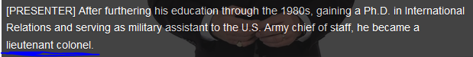

//['kɝnl] colonel: is a high rank in the army, Marines, or the US air force, or someone who has this rank〔陆军、海军陆战队或美国空军的〕上校军衔





//brigadier or ‘brigadier general’ /ˌbrɪɡəˈdɪə/ [N](javascript:;)an officer of the British Army or Royal Marines who holds a rank junior to a major general but senior to a colonel, usually commanding a brigade (英国陆军或皇家海军)准将



//[ major general] an officer of high rank in the British or US army or the US air force少将









## Part2) Military ranks: rank structures in armies

Look at the chart comparing military ranks in the UK and the USA. Note any differences between the two countries and compare the equivalent ranks in your own country. Then group the military ranks according to whether they are in the Navy, Army or Air Force.

Military Ranks

Military personnel are divided into commissioned and non-commissioned ranks. The lowest non-commissioned rank in the British Army is a private soldier.  Corporals, sergeants and warrant officers (WOs) are non-commissioned officers (NCOs). Lieutenants and above are commissioned officers.

It is difficult to draw up an accurate chart to compare the rank structures and titles of the various arms of the military of different countries. This is because individual forces are organised in different ways due to variations in their histories and traditions. Therefore, NATO members use a standardized code that can be found in the document called STANAG 2116. In this system, ranks are codified according to their duties, responsibilities and seniority.

Officers are given the code OF and a number from 1 to 10. OF10 is the highest rank in each arm. For example: General of the Army, Fleet Admiral and General of the Air Force in the U.S. military.

OF1 is a first lieutenant in both the army and air force in the USA and lieutenant (junior grade) in the U.S. Navy.

ORs are other ranks or enlisted personnel. They include privates, seamen or women (crew), and airmen or women (aircrew). ORs also include more senior grades such as warrant officers, petty officers and sergeants.

Military personnel usually enlist in the armed forces as either private soldiers or as junior officers, depending on their education and abilities. Private soldiers can advance through the non-commissioned ranks to warrant officer. Commissioned officers can advance through the commissioned ranks to general, admiral and air marshal.

Commissioned officers spend their careers between command appointments in active units and staff positions within various headquarters. Non-commissioned officers usually spend the bulk of their careers in active units or formations and are often described as the backbone of the armed forces. It is possible in some services for exceptional non-commissioned officers to become commissioned officers.

All military ranks have abbreviated forms. Study the following examples:   
Colonel = Col  
Lieutenant-Colonel = Lieut-Col  
Major = Maj

 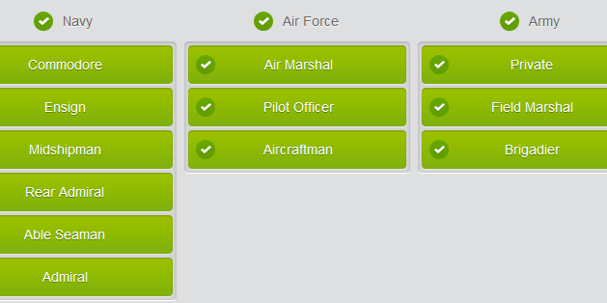

## Military equipment

|  |  |
| --- | --- |
| Type of military equipment |  |
| Land |  |
|  |
|  |
|  |
| Air |  |
| helipad: the apron/tarmac for the helicopter |
|  |
|  |
|  |
| Sea |  |
|  |
| torpedo 复数 torpedoes过去式 torpedoed过去分词 torpedoed现在分词 torpedoing [tɔr'pido] n. 鱼雷水雷；电鳐；职业杀手(hitman); vt. 破坏；用鱼雷袭击 |
|  |
|  |
|  |
|  |
|  |
|  |

Fill in the gaps with the words below.

armored personnel carriers  -  artillery  -  AWACS  -  battleship  -  fighter aircraft  -  helicopter

|  |
| --- |
| Is the largest American warship a battleship or is it an aircraft carrier?  There are hostile enemy aircraft in the area. We need to engage them and reduce their threat. How many fighter aircraft can you allocate to me?  The troops will need to be well protected in case the enemy bombards us with their artillery . The heavy guns could do a lot of damage.  We will need AWACS capability to be able to track other aircraft and communicate with them.  We will need to land troops from the air and insert them into confined spaces by helicopter .  The area is hostile, with pockets of armed insurgents. For better protection we should move the troops in armored personnel carriers . |

## Modal verb , like “should/could/must/can”

modal /ˈməʊdəl/ [N-COUNT](javascript:;)In grammar, a modal or a modal auxiliary is a word such as "can" or "would" which is used with a main verb to express ideas such as possibility, intention, or necessity. 情态动词

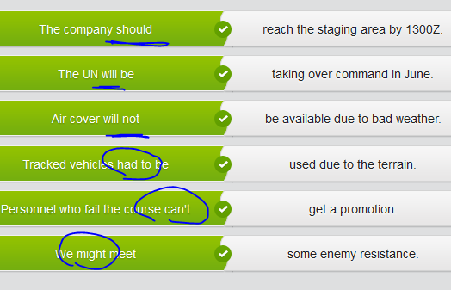

## Giving military career advice

You have been posted to a military careers office where you will advise young people who are interested in joining the RAF. To prepare, you start by reading a career brochure and compiling some notes.

|  |
| --- |
| Career Advice: Joining the RAF, royal aircraft force  Careers are available for men and women irrespective of race, ethnic origin, religion, gender, sexual orientation or social background. (N.B. The RAF Regiment, which is a specialist fighting force, is not open to women, for reasons of combat effectiveness.)  Careers are available for school leavers with minimal qualifications and also for young people who have specialist skills or university degrees. It is unlikely that young people without qualifications will be promoted to the highest ranks. However, it is possible if they gain qualifications during their RAF career. They are encouraged to do so.  School leavers can apply at age 16 and learn a trade through on-the-job training.  Students who have stayed on at school and achieved pass marks or higher in national exams have an increased number of career options available. School leavers will join as aircraftmen or women and during their careers may be promoted to the highest non-commissioned ranks and, in some cases, become commissioned officers.  University graduates enter as officers. Sponsorships are available for students in the last two years at school and/or in university.  There are over 50 different careers in the RAF. Ask the young person about  interests and skills before giving advice about specific careers. Use the materials you have been given, which will help you match the young person with suitable jobs.  Many applicants are interested in jobs that will put them on board aircraft. Explain that this is more likely if the young person is a graduate or has specific qualifications. However, school leavers who join as non-commissioned aircrew (NCA) will train as weapon systems operators and will work on board fixed-wing aircraft or helicopters and may specialize in acoustics, electronic warfare or linguistics. The training for these jobs is up to three years. On completing training, there is automatic promotion to sergeant.  Young people wishing to become pilots can apply on leaving school at 17.5 years old or older. They must have good results in national examinations. They should be encouraged to apply for sponsorship and given advice about subjects to study at school and university. Explain that the young person will be tested in order to establish their aptitude for a career as a pilot. Also explain that once they have completed their elementary flying training, they will be streamed to fly fast jets, multi-engine aircraft or helicopters according to their capabilities. Not all pilots are fighter pilots. Many pilots spend their careers ferrying troops or supplies.  There is a shortage of air traffic controllers. Encourage school leavers to consider this job. They must have a minimum of five good results in the national exams taken at age 16. These must include English and maths. They will have to take aptitude tests and will join as non-commissioned aircrew. |

|  |
| --- |
| RAF CAREERS  - jobs available for men and women in the RAF  - women may not work in the RAF Regiment (for reasons of combat effectiveness)  - school leavers with minimal qualifications can also join the RAF  - the minimum age for school leavers to join is 16  - school leavers will join as aircraftmen or women  - school leavers can sometimes be promoted to commissioned officers  - school leavers who join as non-commissioned aircrew (NCA) will train as weapon systems operators and will work on board fixed-wing aircraft or helicopters .  - They might specialize in acoustics, electronic warfare or linguistics. After completing 3 years training, they are automatically promoted to Sergeant . - University graduates will enter as officers .  - School leavers wishing to become pilots can apply at 17.5 years old or older. They must have good results in national examinations .  - air traffic controllers are in short supply: encourage school leavers to consider this job |

## Part3 Military terms

|  |  |
| --- | --- |
|  |  |
| Land | |  |  | | --- | --- | |  |  | |  |  | |  |  | |  |  | |  |  | |  |  | |  |  | |
| AIR | |  |  | | --- | --- | |  |  | |  |  | |  |  | |  |  | |  |  | |
| Sea | |  |  | | --- | --- | | cruiser |  | |  |  | |  |  | |  |  | |  |  | |  |  | |  |  | |

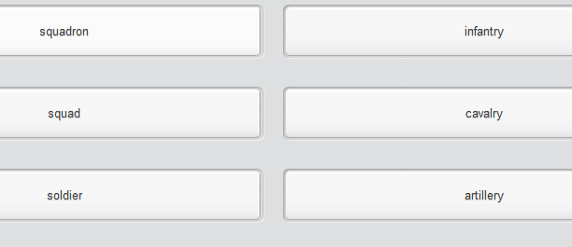

## Imperatives for giving order //imperative mood 祈使句

Listen to the **platoon commander** giving instructions before a house-to-house search.

 [plə'tuːn][plə'tun] n. 排，团

|  |
| --- |
| imperatives  Look at these two sentences and notice the differences between them: • Could you possibly deliver the furniture tomorrow afternoon, please? • Platoon, halt.  In both of these sentences people are being asked to do things.   * **In civilian life** we often use very polite, indirect questions when we want something done. The first sentence shows you an example of one of these polite questions. * **In military life** this is much less common. The orders we give must be clear and direct. In sentence two, the speaker is using an imperative verb to give an order: halt.   **Imperatives are the same form as the infinitive of the verb – the basic form of the verb.** Look at some more examples.  • Fetch me the maps, Corporal. • Captain, when the meeting finishes, pass on my orders to the company. • Everyone put your guns down and raise your arms.  When we want to give a negative order, we use ‘do not’ or don’t. Here are some examples: • Flight Sergeant, don’t forget to complete all the documentation.  • Don’t stand, everyone. Please sit.  Note:  The words ‘always’ and ‘never’ come in front of imperatives in sentences. Look at these examples: • Always fire a warning shot before using any armed force.  • Never board suspicious ships without an armed escort. |
| Platoon, listen up . We have very clear instructions which I'm going to repeat one more time before you go out on patrol.   Remember , do not search inside the houses yourselves. The local police will be searching inside the houses. Provide security for the police officers inside and outside the houses. Search the gardens and outside areas yourselves but let the police officers do the job inside. Behave politely but firmly with the inhabitants. Use the interpreter to explain the reasons for the search. Always make sure that the damage is kept to a minimum. If damage occurs, complete a form and give a copy to the inhabitants of the property.   Never forget that this is private property and most civilians are not involved with hostile actions. Finally, please behave in a professional manner towards our police colleagues and to the civilians. Any questions? |

## Rules of engagement, ROE

You are going to read an article explaining the ‘rules of engagement’ for a NATO mission.

|  |
| --- |
| Rules of Engagement, ROE  Rules of Engagement (ROE) are **a form of written orders** that are produced for every NATO peacekeeping mission. They govern, for example, when and how armed force can be used, how searches should be carried out and the procedures for such things as road blocks or naval blockades. They provide clear guidelines for commanders and troops.  There are some basic principles that appear in all ROEs. An example is the right to self-defense. You will often see the following sentence in ROEs: ‘Self-defense is an inalienable international legal right.’ Inalienable means that no one can take this right away from you. However, this right to self-defense is very specific. It is the use of armed or even deadly force when you are being attacked or when you are about to be attacked. You cannot continue to use armed force after the threat has passed or attack hostile troops when there is no direct threat to your own troops or other NATO troops.  Here is an extract from a peacekeeping mission’s ROE:  General Rules  1. Always use the minimum force necessary. Only use firearms as a last resort. 2. Give a challenge before opening fire. 3. Challenge in English by shouting: "NATO! Stop or I Fire!". 4. Repeat the challenge until you are sure that it has been understood. 5. Use an interpreter to repeat the challenge in the local language. 6. Fire a warning shot. 7. Only open fire against a person who is endangering life and when there is no other way to stop the hostile act.  8. Fire only aimed shots. 9. Do not use automatic fire unless necessary.  10. Fire no more rounds than necessary. 11. Take care not to injure anyone other than your target.  12. Only open fire without challenging when an attack happens unexpectedly, and would result in death or serious injury to you or other NATO personnel. |

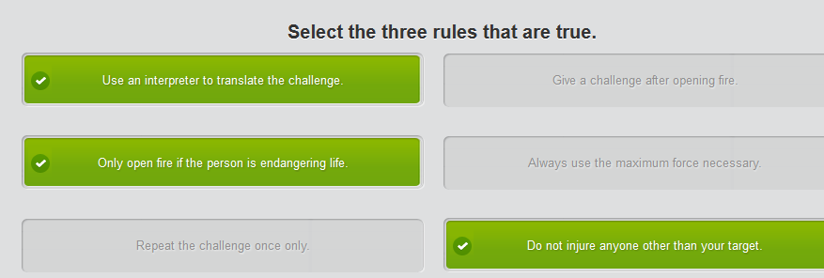

## Giving written order? = ROE

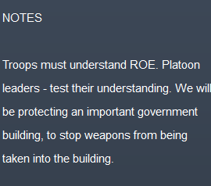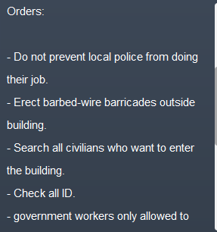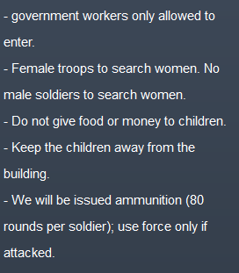

## Part4 Past tenses

**Talking about the past**  
  
There are a number of ways to talk about the past in English. Look at the following examples.  
  
UN peacekeeping **began** in 1948, when UN military observers **were deployed** to the Middle East to monitor the Armistice Agreement between Israel and its Arab neighbors.   
  
The UN **has been involved** in peacekeeping since 1948 and **has arranged** more than 60 peacekeeping operations (PKO).  
  
The first sentence is written in the simple past tense. The second is written in the present perfect.   
  
The two tenses are formed in different ways:  
  
1. The present perfect tense is formed with **has** or **have** and the past participle.  
  
For example:  
  
The UN **has arranged** peace-keeping operations.  
NATO forces **have broken** the deadlock.  
  
2. The past simple tense is formed using the simple past form of the verb. Regular past simple verbs end in **-ed**.  
  
For example:  
  
They **crossed** the border at 07:00 hours.  
  
The two tenses are used in different situations:  
  
1. The past simple tense is used when we are talking about events which happened in a finished time in the past.  
  
2. The present perfect tense is used to talk about events which happened in a time up to now.  
  
The present perfect tense needs the time markers **for** and **since** in order to specify when something happened.  
  
**Since** is used to say when something began.   
  
For example:   
  
The soldiers have been on duty **since** 06:00 hours.  
  
**For** is used when we are talking about a length of time.   
  
For example:  
  
The soldiers have been on duty **for** 24 hours.

Fill in the gaps with either 'for' or 'since'.

* The United Nations has been keeping the peace in Cyprus for many years.
* NATO’s biggest land-based operation was in Bosnia where troops remained on the ground for 9 years.
* The United Nations has been seeking a settlement in Western Sahara since the withdrawal of Spain in 1976.
* NATO has been involved in many missions since the creation of the Alliance in 1949.
* Almost a hundred UN peacekeepers were killed in the Haiti earthquake, the biggest loss of life since UN peacekeeping began.
* In 1988, the Peace Prize went to the United Nations as they had been peace-makers for 40 years.

## Peacekeeping维和 and peacekeepers

A representative is introducing his country's contribution to a peacekeeping mission

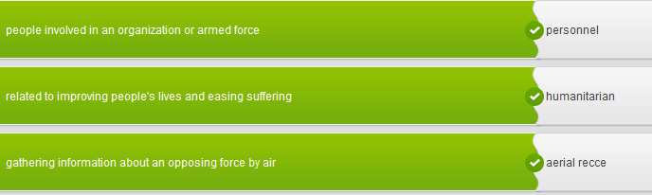

Fill in the gaps. Use the surrounding text and context to help you choose the correct word each time.

humanitarian  -  well-equipped  -  recce/reconnaissance  -  contingent  -

non-combat  -  escorting  -  personnel

|  |
| --- |
| Good morning, ladies and gentlemen. I’m Squadron Leader Anant Badri, and I'd just like to say a few words about the Indian contingent which will be working alongside you here in Molruvia.  We are all members of the Indian Air Force, which is usually abbreviated to IAF. By the way, I don't know how much you know about the IAF, but I'm proud to say that it's one of the world's largest air forces, and we operate more than 800 combat and over a thousand non-combat aircraft. We're a very professional and well-equipped force. We've been going through a period of modernization over the last few years, and this will continue over the next decade.   Our motto is 'Touch the sky with glory,' and our long and distinguished history in UN peacekeeping and humanitarian missions is a witness to the way we live the motto. In fact, India has participated in most major peacekeeping exercises since the Korean conflict in 1950. Today, India is one of the largest contributors to peacekeeping operations around the world, and we have thousands of armed forces personnel and civilian police who are participating in various UN peacekeeping operations.   On this peacekeeping mission we are supplying eight helicopters and two supply aircraft, plus aircrew, mechanics and the usual support personnel, and **the contingent**一批(部队) will be commanded by Wing Commander Mohan Anil. We will expect to be assisting you with troop transport, aerial recce , convoy escorting , evacuations and other tasks.   I'll be going on to give you an example of one of our past peacekeeping missions. So, if anyone has any questions at this point, please feel free to ask. |

## Peacekeeping mission维和任务

Sqn Ldr Badri is going to speak to his international colleagues about a particular operation which India contributed to in the past.

|  |
| --- |
| **Example of Indian contribution to UN peacekeeping**  **Somalia**   - memorable due to film “Black Hawk Down” and the battle of Mogadishu. - very difficult mission  - largely lawless country  - violent rebel troops - starvation in many areas - large number of peacekeepers and military observers killed or wounded in Somalia  We provided evacuation, medical, communication and logistic support.  **Example of the contribution to Somali PKO:**  **Makeni Rescue Operation**  - Contingent was tasked to evacuate three Kenyan battle casualties, plus 11 UN military observers from the besieged garrison of Makeni. - After landing on helipad, our helicopter encountered heavy firing from rebel positions.  - Under fire, we offloaded the supplies and helped casualties and military observers into the helicopter and took off with the rebels still firing at it. - The helicopter was badly damaged, but the pilot was able to fly 10 kms away from the inhabited area before landing.  - They made a mayday call, and another IAF helicopter arrived and was able to pick up all the casualties, crew and military observers while rebel troops began to encircle the helicopters. - The damaged helicopter had to be abandoned. - All personnel were safely delivered to HQ by the second helicopter. - The aircrew of both helicopters were professional and skilled. - This was just one of the important contributions we made to this extremely difficult PKO.  We hope, of course, that the PKO we are currently taking part in will be much more peaceful and without casualties. |

Summarize the siege incident in no more than 50 words.

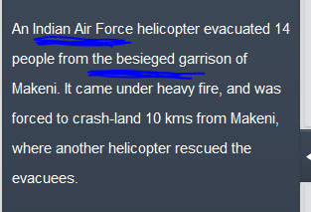

## Giving a briefing on a peacekeeping mission

You represent the French Air Force, and you're preparing to give a briefing to international colleagues on a peacekeeping mission

|  |
| --- |
| The French Air Force or Armée de l'Air (often abbreviated AA):  • is considered  to have been the first professional air force – fought during WWI and first established in 1909.  • has been going through a period of modernization and streamlining. The AA is ready to provide modern, professional and efficient force both in defense of our country and on humanitarian and peacekeeping missions.  • has the motto “Faire face,” which could be translated as “face up to something” or “rise up.” It means that we are ready to act.  • has a lot of experience of peacekeeping around the world, including the difficult Afghanistan mission. This includes the provision of an aircraft carrier, the Charles de Gaulle, with Mirage fighters, C-135 refueling aircraft and troops. It has been a very professional but tricky mission.  Regarding the PKO in Molruvia, the AA:  • will be providing 6 Mirage 2000 fighters, plus support staff and equipment.  • will also be providing personnel and equipment for fighter control and air traffic control.  • will have as its main role to patrol the skies over the country and discourage incursions of airspace by other countries.  • is looking forward to new roles on NATO missions after the decision in 2009 to rejoin the integrated military command structure of NATO. |
| - Many people think that the ALA was the first professional air force.  - The Air Force has gone through a period of modernization and is now professional and efficient .  - Our motto is Fair face, which means something like 'face up to something' or 'rise up'.  - We have lots of experience , including peacekeeping in Afghanistan, which was a challenge but a task we carried out very professionally.   - On this PKO we will be providing 6 Mirage 2000 fighters plus staff and equipment.   - Our main role will be to patrol the skies. |

# **Unit II

## Part 1) Army barracks军队的营房

 ['bærək]barrack 营房



 regiment:?



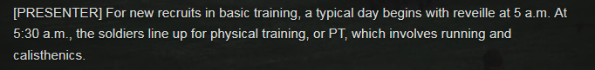

// [,kælɪs'θenɪks] . 健美体操; PT: physical training





//hands-on practice; 精确射击能力, 枪法marksmanship ['mɑrksmənʃɪp]   //BCT



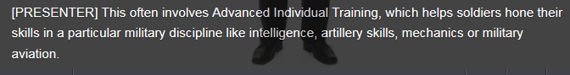

//hone skills; [ artillery skills炮术]



//the drill sergeants

 //lights out: 熄灯就寝时间

//['bærək]barrack 营房



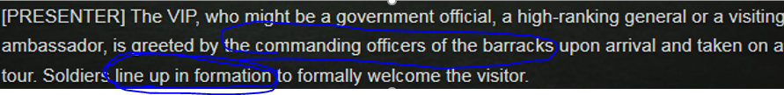

//CO: commanding officers //['bærək]barrack 营房 // line up in formation



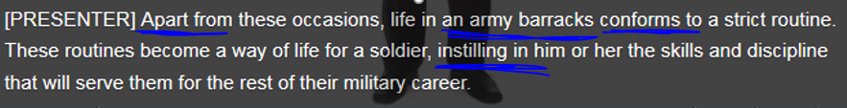

//instill sth in sb. = instill in sb sth给sb.慢慢地灌输;

## Part 2) Facilities on the base

Notice the words below used by the warrant officer to describe routines, rules and regulations. Fill in the gaps. Use the audio to help you.

receive instructions  -  as per battalion orders  -  no exceptions  -  regulation  -  mandatory  -  under your sergeants  -  regime  -  officially excused

|  |
| --- |
| Physical training, or PT, is mandatory every day except Sundays.   You will muster in your platoons outside the gymnasium at 06:30 hours in your regulation PT kit. There will be no exceptions unless you are officially excused for other duties or have a sick note.   After breakfast you will parade in company lines to begin training as per battalion orders and the Training Wing timetable.   You will all parade again at 20:00 hours under your sergeants for administration and to receive instructions for the next day. Lights will be turned off at 22:00 hours.   If not, a remedial training regime will be introduced for all personnel so you have been warned! |

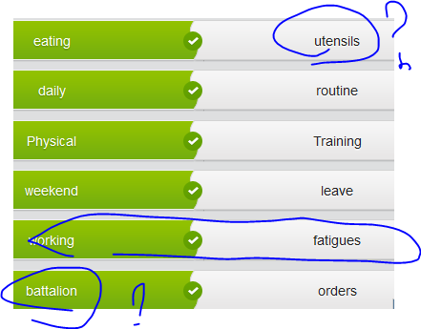

## Military buildings

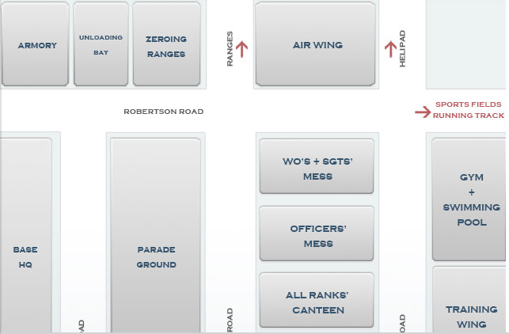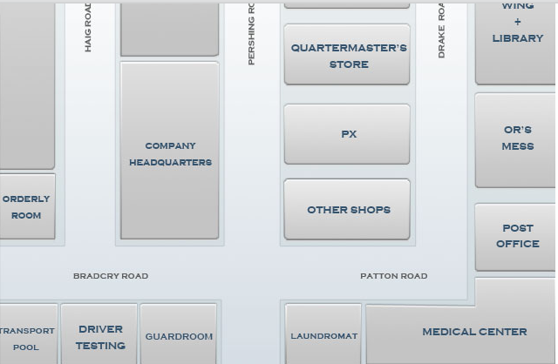

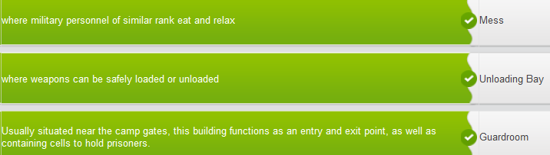

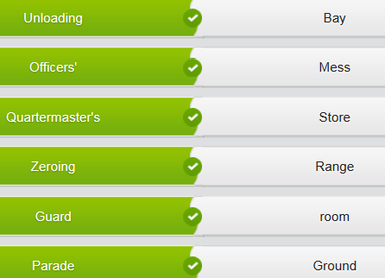

## Modal verb , like “should/could/must/can”

modal /ˈməʊdəl/ [N-COUNT](javascript:;)In grammar, a modal or a modal auxiliary is a word such as "can" or "would" which is used with a main verb to express ideas such as possibility, intention, or necessity. 情态动词

|  |  |
| --- | --- |
| **Modal verbs to give rules** |  |
| A **modal verb** is a type of verb which does not behave in the same way as 'normal' verbs. **Modal verbs** do not change their form by adding **-ed** for a past tense or an **-s** for the third person. They are always followed by another verb which is in the **infinitive** form without 'to'. |

For example:

You **must** practice speaking English as often as possible if you want to become fluent.

**Must** is a modal verb and is followed by the verb **practice**, which is in the **infinitive** form without 'to'.

You **will/should** salute all officers when you are in camp. => modal verb

You **must** wear a uniform at all times when on duty. => modal verb

Before deployment, you **should** take the time to write a will.

You **may** use the internet facilities to keep in touch with your family.

If you have a personal problem, you **can** speak to your commanding officer or the padre or other religious leader, if you prefer. => modal verb

Mobile phones **will not** be allowed on operations for security reasons. => modal verb

You **could** speak to someone in the orderly room if you are having problems with your pay.

You **must** attend sick parade if you are too unwell to do your duties.

## Attending an orientation briefing

You've just arrived at a new base camp and you're at the orientation briefing. The Sergeant is about to describe some of the useful facilities. You've made a list of the ones you need to know about.

## Part 3)

## NATO Alphabet

Telephonic alphabet and numbers = ? the same as radiotelephony?

Using the telephonic alphabet and numbers. How well do you know the NATO pronunciation alphabet?

V.S. radiotelephony: [,reɪdɪəʊtɪ'lefɒnɪ]used in air craft communications between pilots and ATC (air traffic tower controller) 无线电话；无线电话学

|  |  |
| --- | --- |
| The NATO Alphabet |  |
| The NATO alphabet is used by military personnel to avoid misunderstandings in radiotelephony communications.  Words are assigned to the letters of the English alphabet so that they can be pronounced and understood more easily.  This is especially important when speaking over the radio or telephone, or when speakers of different nationalities have to communicate in English.  Study the letters and listen to their pronunciation. |

A     Alpha

B    Bravo

C    Charlie

D    Delta

E    Echo

F    Foxtrot

G    Golf

H    Hotel

I    India

J    Juliet

K    Kilo

L    Lima

M    Mike

N    November

O    Oscar

P    Papa

Q    Quebec

R    Romeo

S    Sierra

T    Tango

U    Uniform

V    Victor

W    Whiskey

X    X-ray

Y    Yankee

Z    Zulu

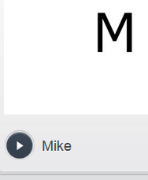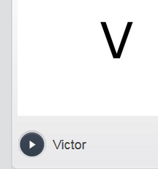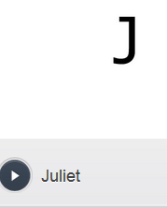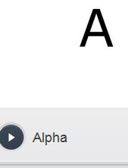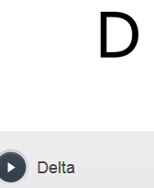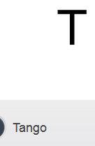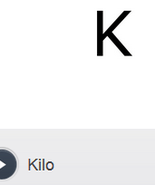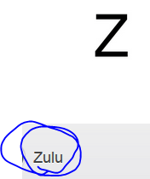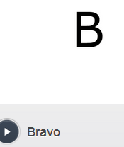

**Zulu Time = 格林尼治标准时间（等于Greenwich Mean Time）: UTC**

|  |  |  |  |
| --- | --- | --- | --- |
| |  |  | | --- | --- | | Saying numbers and the time |  | | In the military there are specific ways to pronounce letters as well as numbers and the time. Study the examples below until you are comfortable saying them out loud. |       **Numbers**  The numbers 0 to 9 are pronounced in a specific way to avoid misunderstandings, especially when speaking over the radio.  0     ZERO 1     WUN 2     TOO 3     THU-REE 4     FO-WER 5     FIVE 6     SIX 7     SEVEN 8     ATE 9     NINER  .      DECIMAL (This is a decimal point.) .      STOP (This is a full stop or period.)  Numbers are usually transmitted digit by digit except for exact multiples of hundreds and thousands, which may be spoken as whole numbers. Numbers are often preceded by the word 'FIGURES'.  Study and repeat the following numbers:  10          "Figures wun zero" 4.5         "fo-wer decimal five" 237        "too thu-ree seven" 500        "five hundred" 3,000     "thu-ree thousand" 13,000   "wun thu-ree thousand"  **Time**  Exact hours are spoken as follows: 0100     zero one hundred hours 0400     zero four hundred hours 1200     twelve hundred hours 1500     fifteen hundred hours  0215     zero two fifteen hours 0530     zero five thirty hours 1345     thirteen forty-five hours 2050     twenty fifty hours  The time 0000 is not usually used as it can cause confusion. Instead, 2359 hours or 0001 hours are used. When coordinating missions across several time zones, the military uses Greenwich Mean Time (GMT). This is known as Z or Zulu time. The letter Z is placed at the end of the time notation: 2300Z. (Twenty three hundred hours Zulu.) |

## Using the radio (military jargon)

When making radio transmissions, military personnel use PROWORDS, or special radio procedure words, which are used by military personnel to help avoid misunderstanding.

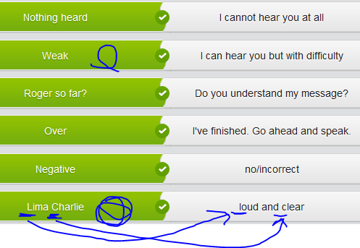

‘Sunray’ is a code name for ___commanding officers, CO__

‘Hotel’ is a code name for _____helicopter //helipad

‘LOCSTAT’ is an abbreviation for _____location status.

‘SITREP’ /si strep/is an abbreviation for _____situation report.

‘PERSREP’ means __personnel___ report.

A ‘FRAGO’ or fragmentary operation order is _____.

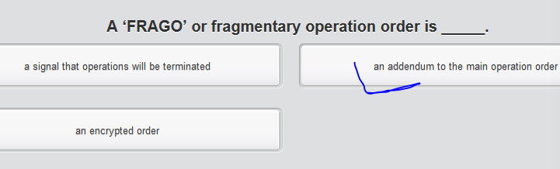

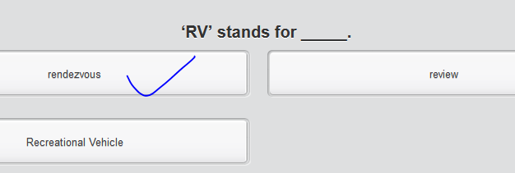

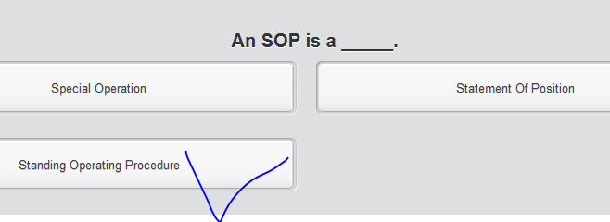

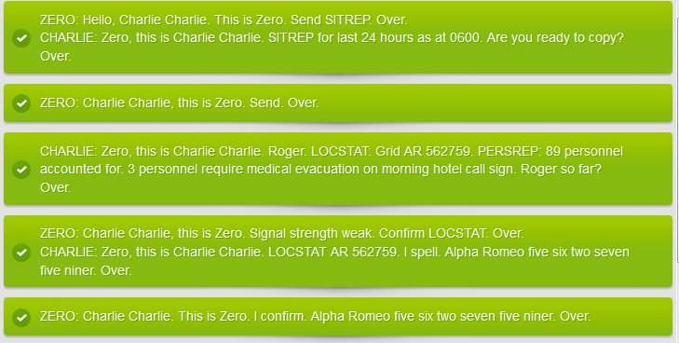

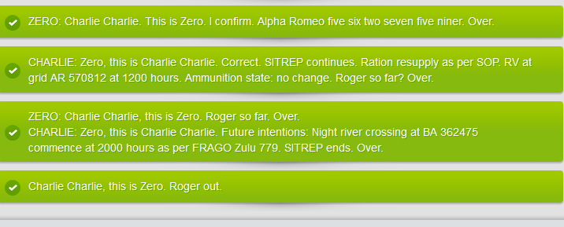

|  |
| --- |
| SITREP 008  PERSREP: 206  MEDICAL: 8 sick, 2 casevaced  RATION REQUIREMENTS: 435 x 24 hour ration packs for exercise on Wednesday  POL REQUIREMENTS: 300 jerry cans of petrol and 200 jerry cans of diesel  AMMUNITION REQUIREMENTS: 8,000 blanks / 250 night flares  HELICOPTER:Helicopter required Wednesday 0700 for troop lift for exercise on Wednesday.Roads cannot be used due to heavy rain and flooding. |

## Write a report by using the radio jargon

Your superiors want you to write a report based on the events

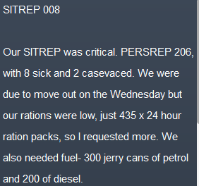 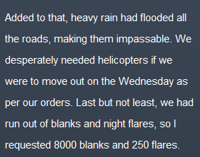

## Part4)

Match the military terms to their definitions

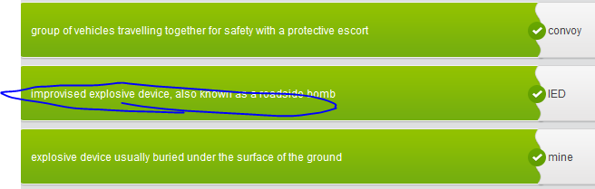

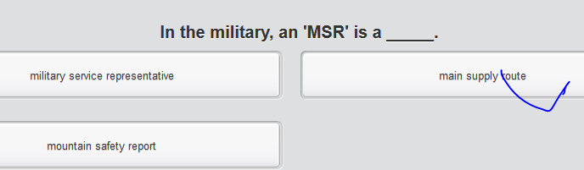

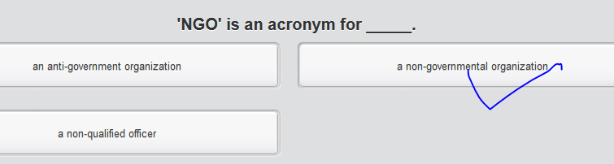

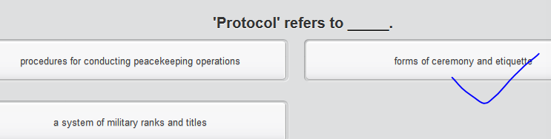

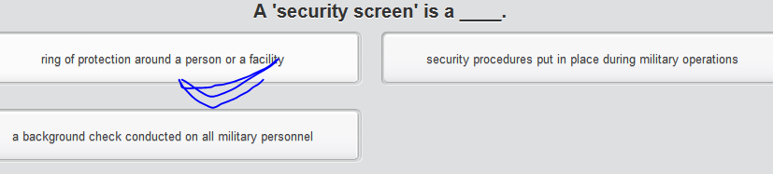

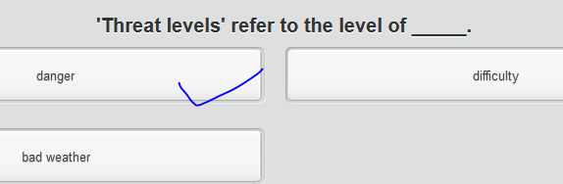

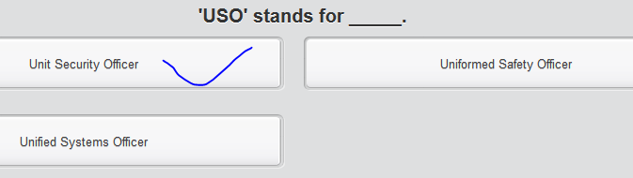 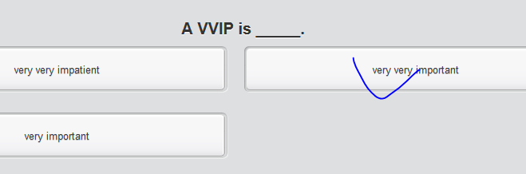

## A VIP visit

Fill in the gaps with the words below.

convoys  -  embedded  -  hours of darkness  -  IEDs  -  military courtesy -  NGOs  -  protocol  -  curfew  -  security screen  -  threat levels

|  |  |
| --- | --- |
| [38 Unused coupons](https://ec.ef.com.cn/school/mini/classbooking/today)  Unit overview   |  | | --- | | https://cns2.ef-cdn.com/Juno/10/98/03/v/109803/LI_Mil_2.1_learning_web.jpg  **1** Learning discipline as a soldier  https://cns2.ef-cdn.com/Juno/10/98/04/v/109804/LI_Mil_2.2_attending_web.jpg  **2** Attending an orientation briefing   * 1   Vocabulary  A VIP visit  Continue   * 2   Function  Giving orders and advice   * 3   Reading  Skimming, scanning and reading for detail   * 4   Final Task  Preparing for a VIP visit  https://cns2.ef-cdn.com/Juno/10/98/05/v/109805/LI_Mil_2.3_using_web.jpg  **3** Using the radio on exercise  https://cns2.ef-cdn.com/Juno/10/98/02/v/109802/LI_Mil_2.4_preparing_web.jpg  **4** Preparing for a VIP visit |   A VIP visit  • • • • Fill in the gaps with the words below.  convoys  -  embedded  -  hours of darkness  -  IEDs  -  military courtesy -  NGOs  -  protocol  -  curfew  -  security screen  -  threat levels  Personnel should also study the security information published today. The threat levels have increased and a number of IEDs have been discovered on major routes.  Embedded journalists are requested to adopt similar standards of military courtesy to officers and soldiers.  Please find attached the program for the forthcoming official visit. Pay particular attention to the sections which concern protocol and correct behavior.  During the visit, the USO will be putting into place a security screen around the camp. Press and civilians should check that all their documents are in order.  It is advisable that personnel should travel in convoys on MSRs. This includes members of the press and NGOs .  The curfew will begin on Monday 09 July and, each day, will last throughout the hours of darkness . All civilian personnel including members of the press must stay indoors.  s |

## Giving orders and advice

Listen to a liaison officer advise a military unit prior to a VIP visi

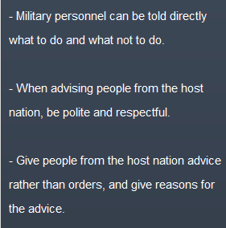 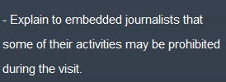

Fill in the gaps. Use the audio to help you.

permitted  -  must  -  request  -  advice  -  orders  -  should  -  advisable  -  allowed  -  prohibited

|  |
| --- |
| 1. Soldiers can be told what they must do.  2. They also need to know what they are not allowed to do.  3. They must understand what is permitted and what is prohibited .  4. So, of course, you will speak plainly and give orders to the military personnel under your command.  5. We should not order them to do things, but request that they do as we ask.  6. Say that they should do this or that and not that they must do it.  7. Give reasons for your advice .  8. You should say, for example, that it’s advisable not to travel after dark because of the threat. |

## Giving orders and advice

An officer attending the talk has to give orders to the soldiers under his command, and must advise the Press and NGOs what they must do during the visit. Use the transcript of the liaison officer’s talk to complete the sentences below. Pay particular attention to the highlighted words and to the advice the officer give

|  |
| --- |
| As you know, giving instructions to military personnel, even members of the Air Force, is not a problem as long as the instructions are clear and reasonable. Giving the same messages to embedded members of the press, to the host nation attachments and to locally employed civilians is more difficult. Although they are all under the same military law when attached to the unit, we must be more diplomatic when we talk to them.  Military personnel can be instructed in a very direct way. Soldiers can be told what they **must do**. They have to be quite certain what they must do. They also need to know what they are **not allowed to do**. They must understand **what is permitted and what is prohibited**. That is the responsibility of the military chain of command and unless the situation is clearly understood, things can and will go wrong. So, of course, you will speak plainly and **give orders** to the military personnel under your command.  However, when we’re talking to people from the host nation who are working with us, it’s important that we respect their sovereignty. We **should not order them to do things** - but **request that they do as we ask**. Be less direct and sound as if you are advising them. For example: Say that they should do this or that and not that they must do it.  Say, for example, that they can do what they want to do, but that they should be aware of the consequences. **Give reasons for your advice**. For example: Explain that they can take photographs of the visitors to show to  their mothers but that in the background there might be some equipment or activity that could help the insurgent. Therefore **it isn’t advisable**.  In the same way you should take care when talking to  the embedded civilians such as journalists and NGOs. It must be explained that the orders and instructions for the official visit are for the overall good of everyone and are not designed to restrict or censor their activities. Be careful when you are briefing them. You should say, for example, that **it’s advisable** not to travel after dark because of the threat. **Don’t order them** not to travel. Or, for example, you could say that **our advice** **is** that it is best not to interview soldiers without the Press Officer present, because they might accidentally compromise security which could have tragic results.  Also, **explain** to our embedded colleagues that they are **permitted** to work as normal but that in the wider interests of the VVIP visit certain activities will be temporarily **prohibited**. However, they may **be allowed to** do them if they apply for special **permission** through the correct channels. In all cases it ought to be made clear that there could be exceptions to the rule, but that **it is advisable** that they ask a responsible member within the chain of command first.  Choose your words wisely and, I hope, we will have no diplomatic problems during the visit. |

## Skimming, scanning and reading for detail

A military unit is expecting a visit from some important people and the security arrangements have been published. Skim through the attached Special Security Order in order to discover the general topic of each paragraph. Put the paragraph headings in the correct sequence.

**RESTRICTED  
STAFF-IN-CONFIDENCE  
  
SPECIAL SECURITY ORDER**

Reference:  
  
A. Force Standing Security Orders dated 30 January 2010.  
  
**Caveat**  
  
The following instructions apply to all military and attached or embedded civilian personnel, including non-government agencies (NGOs) and media, subject to force security orders at Reference A. You should brief them to your teams who ought to be clear that they will be strictly enforced in the interests of the mission.  
  
The mission will host a VVIP visit next week, which directly affects your normal daily tasks and routine. Exact timings are withheld for security reasons, but you are advised to review your protocol procedures and planned activities. Normal activities will be permitted as much as possible but may be subject to restrictions.  
  
Normal movement will be restricted during the visit and rehearsals for security reasons. You should not plan convoys in the hours of darkness as main supply routes (MSR) ‘Charlie’ and ‘Rose’ will be closed to non-urgent traffic. Our advice is to clear any tasks through the operations cell if in doubt.  
  
All are reminded you must obey VVIP security instructions concerning the proposed visit. A press instruction will be released in the next few days. A curfew will be imposed once exact details and timings are made public.  
  
Appropriate national and international protocol measures will apply. This could involve a formal parade for military personnel and various opportunities for attached civilians, NGOs and press to meet the entourage. A detailed program will be released soon and variation from it will not be tolerated. All personnel will be permitted to meet the visitors but are reminded that a high standard of courtesy and politeness will be expected. Any attempt to deliberately embarrass our visitors will be dealt with severely.  
  
A press release will be published in the next few days. Meanwhile, personnel are to adhere to standing press instructions. No unauthorised comments to the press, including embedded correspondents, without prior clearance through the Unit Press Officer (UPO) are permitted. There will be considerable international, national and local interest in the visit, and provision will be made to accommodate this. It will include local interest stories for the regional press in your home towns.    
  
You are advised that photography, other than by authorised persons, will be restricted and the use of private mobile phones could be banned. Similar restrictions may apply to recording devices. Please check with the Unit Security Officer (USO) before using cameras, recording devices or mobile phones.  
  
**Transport Arrangements**  
  
The VVIP visit will involve a combination of road and helicopter movement. The helicopter reception team and fire prevention crew are to be fully rehearsed under arrangements of the Air Movement Officer (AMO). All motor transport arrangements are to be coordinated by the Motor Transport Officer (MTO) in liaison with the Operations Cell.

**RESTRICTED  
STAFF-IN-CONFIDENCE**

## Preparing for a VIP visit

You are expecting a VVIP visit tomorrow. Read the Security and Protocol document and sort the information under two headings: Security, and Personal conduct and preparation.

|  |
| --- |
| **RESTRICTED STAFF-IN-CONFIDENCE**  **VVIP Visit: Security and Protocol**  **General:** Arrangements have now been finalised for tomorrow’s VVIP Visit. The visitors will include royalty, heads of state, senior diplomats and military officers.  **Security:** In view of the sensitive nature and the deteriorating security situation, the security level will be raised to Red Alpha with immediate effect. A detachment of security specialists has already arrived and is liaising with the Unit Security Officer (USO), the military police and the host nation security agencies. A curfew is now in force and all security orders are to be obeyed without exception by all military personnel and embedded civilians.  **Protocol and Military Courtesy:** The highest level of protocol - that is, ceremony and etiquette - as well as military courtesy, is to be observed at all times. Despite the operational nature of this mission, peacetime rules will apply.  **Forms of Address:** Visitors are to be addressed as "Your Royal Highness," "Sir," "Ma'am" or "Mister" as appropriate. Head dress ought to be worn at all times by all ranks and salutes are to be delivered and acknowledged – despite the operational  environment. You may shake hands if offered to do so by the visitor. Military personnel are to introduce themselves using their rank and surname only. There is no need to use your regimental number. When invited, you may discuss your mission in general terms but avoid operational detail as members of the press will be present. If in doubt, you should refer the question to someone more senior. National politicians and regional press may be interested in where you come from for local interest stories. If selected, you will be advised by the Unit Press Officer.  Civilians should adopt appropriate practice as advised in their administrative instructions.  **Standard of Dress:** Dress for the military will be clean, pressed combat uniform, with berets and appropriate badges of rank and mission insignia. No weapons are to be carried other than by the Duty Company and external reinforcement. The Duty Company will be issued weapons to be drawn today at 1800 hrs and ammunition, which will be drawn at 0700 hrs tomorrow. Weapon cleaning parade for Duty Company will be at 1830 hrs today. Embedded NGOs, press and other civilian personnel are encouraged to wear a jacket, shirt and tie, or female equivalent. They should present themselves in a clean, washed and preferably shaven condition as appropriate. The barber’s shop is open now and will close at 2000 hrs and the mobile shower units will open at 0600 tomorrow.  **Guard of Honour:** There will be a Guard of Honour mounted by Alpha Company, wearing Service Dress No. 2 uniform as already advised by the Regimental Sergeant Major (RSM). The highest standard of drill and turnout must be observed. There will be a rehearsal parade at 1200 hours today in working dress.  **Visit Timetable:** A detailed list of visit serials will be confirmed later today. They will include a parade and march past, speeches,"meet and greets,", walkabouts and receptions at the various mess halls. The visitors will have lunch in the Warrant Officers’ and Sergeants’ Mess and dinner in the Officers’ Mess. There will be a demonstration of operational capability tomorrow afternoon as advised by the Operations Officer and Training Wing.  **Summary:** The highest standards of deportment, briefings and general conduct are mandatory to create a good impression of the unit and its fitness for role. Any person found transgressing the security orders, operational instructions and protocol standards required to make the visit work will be severely dealt with. To this end, the bars will be closed from immediate effect and there will be no consumption of alcohol until further notice.  **RESTRICTED STAFF-IN-CONFIDENCE** |

# STOP **Unit III

## Part1) “Combat medics” 战斗医务人员









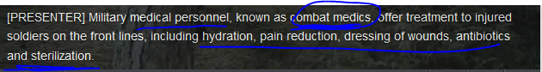

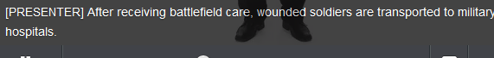













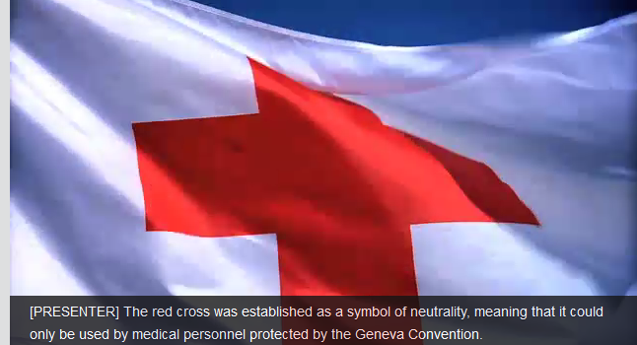

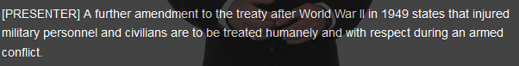

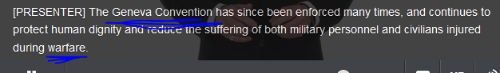

## STOP

## Part2)Make a radio call for help

## Parts of the body, wounds and illnesses

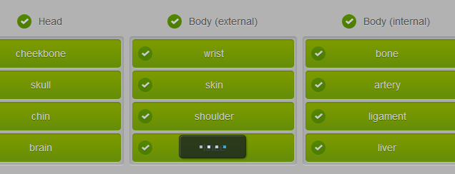

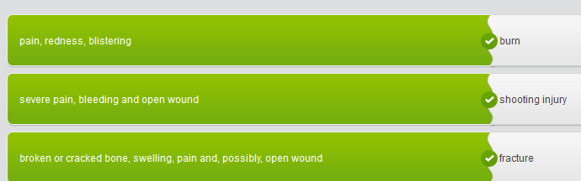

Complete the sentences using the medical vocabulary below.

ambulatory  -  CASEVAC  -  CCP  -  field dressings  -  litter  -  MEDEVAC  -  medics  -  morphine  -  triage   -  triage tags

|  |
| --- |
| A cruise ship passenger had to be removed from the ship due to a medical emergency. The MEDEVAC was completed by air ambulance.  After the battle, there were a large number of casualties. The medics carried out the triage process and sorted the patients into urgent, priority or routine cases.  The casualties were assessed and triage tags were completed and attached to each one so that they could receive treatment quickly in hospital.  Field dressings were applied to wounds and morphine was given to casualties who were suffering the worst pain.  All the patients were gathered together in one area, known as the CCP or casualty collection point ready for CASEVAC by helicopter.  Some patients were ambulatory or walking wounded. Others had to be carried to the helicopter on a litter . |

## Describing a medical situation

Listen to this discussion between a doctor and a patient. They are talking about the symptoms the patient is suffering from. Put the pieces of the dialogue in the correct order.

|  |
| --- |
| When there are multiple casualties on the battlefield it is important that you start a triage process. Triage is the process we use to sort the casualties on the basis of how severe their injuries are. We also have to decide whether they need immediate medical attention .   With each casualty you should first check if they are breathing . If they aren’t, you must check their airway and clear it if necessary. You should also treat any obvious, external , life-threatening bleeding . Unresponsive patients should be put in the recovery position while you move on and continue the triage process.   A triage tag should be attached to each casualty you have dealt with. Look at the tag in your folders. There is an instruction leaflet which you can study later, but, basically the tag will show the location of injuries, any vital signs you have taken, such as the pulse, and whether you have given the patient any medicines . Most importantly it will also show whether the patient is a priority or non-urgent case.   All casualties should be taken to a CCP or casualty collection point. One of the walking wounded can be put in charge of the non-urgent cases.   When calling in a CASEVAC request remember to give accurate information about the number of casualties in each category. The three categories will be: urgent, priority and routine . It is also important to say how many patients are able to walk and how many will need  stretchers . |

## The Geneva Convention[dʒi'ni:və] 日内瓦

Read the article about the Geneva Conventions.

|  |
| --- |
| **Geneva Conventions**  The Geneva Conventions are the basis of modern international humanitarian law regarding armed conflicts.  They specifically protect people who are not taking part in the hostilities, such as civilians, health workers and aid workers; and those who are no longer taking part, such as the wounded, the sick and also prisoners of war. It includes **combatants** who are hors de combat, such as shipwrecked soldiers and sailors or personnel from downed aircraft. Military chaplains and other religious personnel are also included in this list of protected people unless they are carrying weapons and taking part in hostilities.   * + //combatant **/** [kəmˈbætənt/ A combatant is a person, group, or country that takes part in the fighting in a war. 参战者 •  I have never suggested that U.N. forces could physically separate the combatants in the region.   我从未表示过联合国部队能将该地区的参战者们实际隔离开。   There are four Geneva Conventions that cover armed forces on land and at sea, prisoners of war and civilians. There are also two protocols that are additions to the conventions and which take into consideration modern means of warfare and give more protection to vulnerable people in international and national conflicts (civil wars).  The basic principles of the conventions are that the dignity of individual people must be respected at all times, and everything should be done to reduce the suffering of people who have been put out of action by sickness, wounds or captivity, whether they are **combatants** or civilians (or non-combatants).  //combatant **/** [kəmˈbætənt/ A combatant is a person, group, or country that takes part in the fighting in a war. 参战者 •  I have never suggested that U.N. forces could physically separate the combatants in the region.   我从未表示过联合国部队能将该地区的参战者们实际隔离开  The conventions also define the use of the red cross, red crescent and red crystal. These symbols must not be misused. They should, in peace or war, only indicate and protect medical personnel, medical transport, medical materials and medical buildings, tents, etc. They should not be used to protect or hide military equipment or active military personnel.  The first and second Geneva Conventions cover land and sea forces and state that, when members of the armed forces are wounded or sick and therefore cannot continue to take part in hostilities, they become vulnerable people and should receive protection and care.  Members of enemy forces who are wounded or sick should be treated as carefully as members of your own forces and, after battles, you must search for the dead and wounded of both sides to protect them.  Every effort should be made to confirm death by medical examination, to collect the dead quickly and to protect them from robbery.  The third convention concerns prisoners of war and covers various aspects of their care, including their medical care. It also states that POWs should be repatriated if they are seriously ill or wounded.  The fourth convention concerns civilians who are in the hands of enemy forces or an occupying power. As with prisoners of war, they must be treated humanely and with respect. |

## Making a radio call for help – radiote’lephony

You are preparing to take part in an active mission and are doing some preparation at Battalion HQ. While you are there, you hear a MEDEVAC radio message concerning your unit, and have to take note of the key information. Listen to the radio message and complete the sentences by selecting the correct answer

|  |
| --- |
| Zero, this is 69. MEDEVAC. (Location of Casualty Collection Point) Grid ZA 456012 (Frequency and call sign of CCP) 99.60. Mike 28  3:  (Number of patients by medical urgency) A:  (Urgent) 15 B:  (Priority) 21 C:  (Routine) 30  4: (Special equipment) B: (Hoist to lift patients)  One C: (Extraction equipment - to get patients out of difficult positions e.g. from under vehicles) Two sets D: (Ventilator - to help patients breathe) Three  5:  (Number of patients by type) L:  (Litter – also called a stretcher, used to carry patients) 36 A:  (Ambulatory – patient able to walk)  30  6:  (Security of CCP – casualty collection point) E:  (Enemy in area) MSR Horse going north X:  (Armed escort needed) Affirmative with ground and air cover  7.  (Method of marking pickup site) A:  (Panels) Yes B:  (Pyrotechnics) No C:  (Smoke) Yes. Purple D:  (Other) Red Cross Flag and LZ sign on roof E:  (None) Negative  8:  (Patient nationality and status) A:  (Military) 16 B:  (Civilian) 40 C:  (Enemy) 10  9:  (NBC Contamination) A:  (Nuclear) Nil B:  (Biological) Nil C:  (Chemical) Possible napalm |

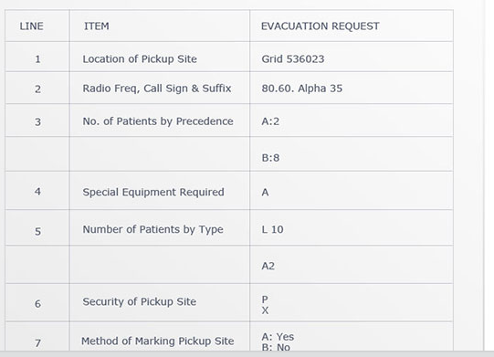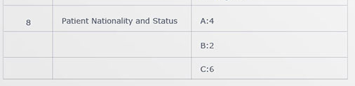

## Part3)

## Different types of interventions  介入；调停

Practice vocabulary describing military interventions into other countries

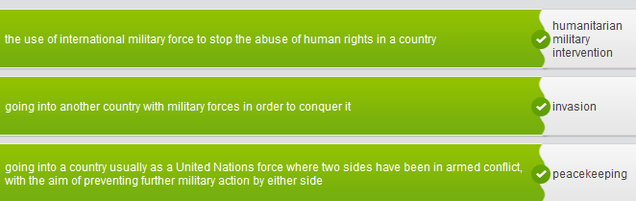

Use the new vocabulary to complete these sentences about the history of military interventions.

peacekeeping  -  humanitarian military intervention  -  invasion  -  intervasion  -  military intervention  -  peace enforcement

|  |
| --- |
| United Nations' peacekeeping forces can be found in many troubled areas around the world where they often work as a buffer between formerly conflicted forces.  The UN has resisted calls for peace enforcement in the past but after Belgian soldiers were forced to watch a massacre and were then killed, the organization is under pressure to go further than just peacekeeping in future.  On 19 September 1994, U.S. troops began an intervasion of the country of Haiti to assist the democratically-elected Government to regain power.  The German invasion of the Soviet Union during the Second World War caused an enormous loss of life and was, ultimately, unsuccessful.  'Although insurgents appear to be gaining ground in Pantasia, there is no possibility of military intervention by our forces,' said the Foreign Secretary.  Some people argue that the international response to the troubles in the Balkans in the 1990s can be classified as humanitarian military intervention as the aim was to protect civilians and bring an end to the hostilities. |

## Past simple and past perfect（动词的）过去完成时

Practice using the past simple tense to talk about things which happened in NATO history. Select the correct verb from the list below, and put it the simple past tense.

be  -  found  -  have  -  leave  -  move  -  sign  -  withdraw

|  |
| --- |
| The first Supreme Allied Commander Europe (SACEUR) was US Army General Dwight D Eisenhower.  SHAPE (Supreme Headquarters Allied Powers Europe) and NATO's HQ moved from France to Belgium after the withdrawal of France.  The most significant event of the 1960s was that France withdrew from the military side of NATO.  Twelve countries founded NATO on 4 April 1949 when they signed the North Atlantic Treaty in Washington, DC, USA.  General Eisenhower left his post as SACEUR in 1952 in order to run for the presidency of the USA.  The Cold War and the increase in the Soviet Union's power had a powerful influence on NATO. |

Language focus

|  |  |
| --- | --- |
| Past Perfect（动词的）过去完成时 |  |
| We use the past perfect when we want to show that something took place and finished before something else in the past. We can often use the simple past instead, but we choose the past perfect to make it clear that one action had ended before another one occurred. |

Look at the following examples. The past perfect is in bold.

The fighting **had stopped** by the time the UN forces arrived.   
The rebel army **had withdrawn** their troops before the NATO forces arrived.

In these examples, there are two actions which both happened in the past.  The past perfect shows which action happened first.

## Special forces

Read and study the information about Special Forces operations in the Balkans

|  |
| --- |
| **Special Forces in the Balkans**  Special Forces were used on a number of operations during the NATO Balkans campaign. Sometimes their unconventional warfare skills were needed to achieve symbolic results to reinforce the overall mission to implement and then stabilize peace. There was public pressure to bring Persons Indicted for War Crimes (PIFWC) from all sides to justice at the International Criminal Tribunal (ICT).  There were various stages required before committing Special Forces to sensitive operations. First, there had to be the political will to allow planning for such missions, followed by the political authority to carry them out. Once planning permission was granted, the staffs and units concerned had to undertake a number of other functions to ensure success.  The most important part of planning was to mount intelligence operations to gather the necessary information. These too required special permission from the highest level and strict security measures to protect them. Once sufficient information was gathered, planning the actual mission to capture PIFWCs began. This involved a number of coordinating meetings, which considered various options and which were updated with new intelligence. From these meetings, concrete operational orders were written and produced.  Before any military operation, it is important to train, rehearse and exercise all the troops taking part. This also happened in the Balkans campaign, with Special Forces rehearsals often disguised within normal training activity to protect the security of the actual missions.  When the forces had been fully prepared, they were put on standby to deploy, waiting for specific intelligence on the whereabouts of the PFWIC targets. Once confirmed, political authority to proceed was checked, and the operation launched.  During the actual operations there were adjustments to cope with"the heat of the battle" using contingency plans that had already been prepared. Once complete, the Special Forces contingents and captured PIFWC were then extracted to a safe location, usually by helicopter. The captured PFWICS were checked medically and put into the custody of war crimes investigators, which was normally a civilian authority. This was done as soon as possible in order to preserve evidence, and the PIFWDs were then subsequently moved to The Hague. The soldiers who had been involved were debriefed and gave statements, which might later be needed for evidence and record keeping. After these procedures, operational staffs would evaluate ‘lessons learned’ from all aspects of the completed mission and feed them into other Special Forces operations. |

## Giving a briefing for a mission

You are in command of a unit which has been on standby to deploy on UN missions. You have now been informed that the unit will be deployed on a peacemaking and peacekeeping mission to the country of Pantasia. As part of your preparation you have been given some background information about the conflict.

|  |
| --- |
| **Confidential**  PANTASIA – Background Information for Deploying Units  The situation in the Federation of Pantasia began to cause the international community concern a year ago when an election resulted in a vote to break up the federation and form two separate countries for its two main ethnic groups, the Alphas and the Betas. Fighting broke out for control of the mineral-rich Argos Region, as well as between certain minority groups who were made refugees. There is also evidence of an attempt at ethnic cleansing of a minority group.   Six months ago the military staged a coup to reunite the Federation. Although a large portion of the armed forces have returned to Federal control, elements have remained loyal to the new governments of Alpha and Beta. These armies have had small battles between themselves over disputed territories while resisting operations by the Federal forces based in Federal Territory.   Until a month ago the situation was a stalemate, however, the various factions have been rearming under the pretence of negotiations. Recently, strong leadership in Beta has resulted in a campaign that has pinned down Federal forces and Beta forces have also launched an all-out attack through Alpha territory to seize valuable land in Argos.   This has resulted in considerable civilian casualties, refugees and dislocation of population. There are reports of executions, rape, destruction of property and infrastructure. It is also believed that Beta has established concentration camps as part of its ethnic cleansing policy.  Apart from the problems of the ongoing conflicts, there has been the constant threat of hunger for the civilians in the area.  Earlier in the year the weather was unusually cold and dry, which resulted in crop failures. In recent weeks heavy rains have caused flooding and the destruction of bridges, roads and rail links, cutting off some of the most vulnerable villages.  As a result of the conflict and because of humanitarian concerns, Chapter VII of the UN Charter was invoked by a special resolution with strong rules of engagement (ROE) to impose peace, separate the warring factions and provide humanitarian care. An Implementation Phase, involving air power supported by ground troops, will be launched at 0600 hours on Monday unless the factions lay down their arms. This seems increasingly unlikely.  In addition to war-fighting the infantry units will be expected to conduct humanitarian operations, to protect people and improve basic facilities. The Implementation Phase is expected to last one month and then turn into a Stabilization Phase, although it is possible that the war fighting phase will last longer. During the Stabilization Phase, infantry units will be ensuring peace and security while a new government takes over and NGOs enter the country to assist the civilian population. Some units will also be involved in direct humanitarian work.  **Confidential** |

You are preparing to brief your troops about the unit’s deployment. Read the information again and make notes on the main points.

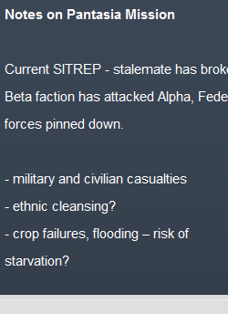 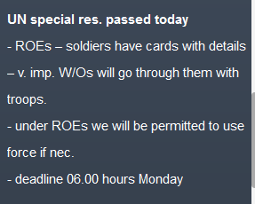 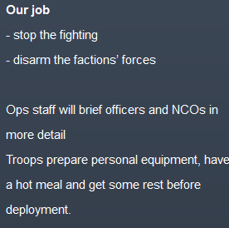

# Part4) Military documents

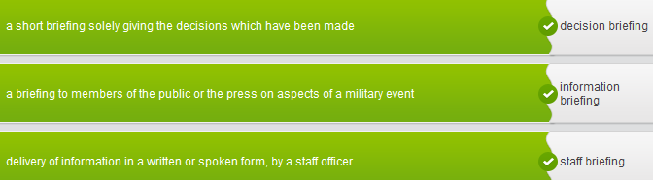

The Staff Officer ____**delivered_ a briefin**g to the General using a selection of PowerPoint slides.

**A __press___ briefing** will be given at 0900 hours tomorrow.

All senior officers are expected to ___**attend__ a briefing** at 0800 hours on Thursday 1 June.

You will be expected to _**brief/debrief____ the General** on the progress of the campaign.

If you _**draft_ the brief**, I will check it for you before you complete the writing.

You are required to give a(n) __**oral_ briefing** to the Commanding Officer at the end of each day.

The text below gives a general definition of military-style briefings. Complete the paragraph by typing into the blank spaces. Choose from the words below.

audience  -  understanding  -  goal  -  concise  -  effective  -  facilitate  -  objective  -   specific  -  well-informed  -  civilian

The basic principles and technique for ? debriefing?

|  |
| --- |
| The basic principles and techniques of effective writing are the same in civilian and military life. Military-style briefings, however, tend to be more concise and written in plain, direct English. The facts are written in an objective and unemotional way. Most military briefings are written about specific situations or sets of facts and are directed at a specific audience . Military briefings are used primarily to keep commanders and staff well-informed and focused. The goal of all briefings is to enable the reader to have a thorough understanding of the facts in order to facilitate decision-making. |

## STP Military writing

Read these tips for effective military writing. Complete the sentences using words from the box below.

edit  -  illustrations  -  briefing  -  outline  -  key  -  questions  -  clearer  -  errors  -  practice  -  analyze

|  |
| --- |
| Firstly, you should analyze the task and think about who is to be briefed and what type of briefing is needed.   Then, collect the information you will need. Arrange the key points in logical order and draw up an outline for the briefing before writing the first draft.   Prepare any illustrations or visual aids which will help you to make your points clearer .   Revise and edit the draft, taking care that there are no spelling or grammar errors .   If you are going to deliver the briefing orally, practice reading it out loud.   Think about any questions you might be asked and prepare your answers. |

Open with a short, clear sentence to explain the _purpose____ and scope of your briefing.